Easter Day April 12, 2020

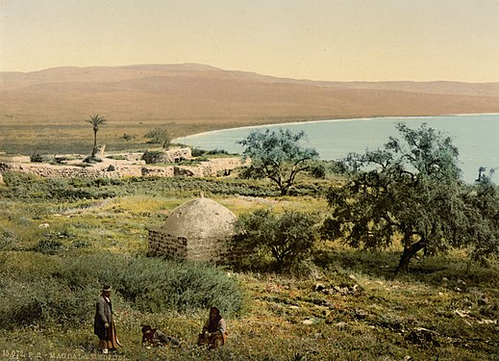

Photograph taken c. 1900 of the ruins of Magdala, Mary Magdalene's hometown^{[15][16][17]}
Today’s gospel is a love story. The protagonist is Mary. She grew up in the fishing village of Magdala, on the western shore of the sea of Galilee. According to John’s gospel, she witnessed the crucifixion, the burial and the empty tomb. Luke’s gospel tells us that earlier, seven demons were driven out from her, prompting her love for the one who had saved her from despair.

Her devotion reflects the compelling personality of the one she loved and followed. Today’s gospel has Mary arriving at the tomb before sunrise. Did she even sleep during the previous hours? When she sees the stone removed from the entrance to the tomb, she doesn’t wander back, she runs to tell the others, including the disciple whom Jesus loved, to report what she has seen.

How very human the story is; not dispassionate, not elevated prose. No one knows who the one Jesus loved was. We know he loved Lazarus, the brother of Martha and the other Mary, to whom he gave new life. Or was it John the son of Zebedee? Perhaps it doesn’t matter. For what DOES stand out is love, forged within the context of the cross, the Roman oppression, the wandering in the wilderness. LOVE stands every time a disciples experiences somehow the risen Christ, the focus of their hopes and a focus of our worship today.

Mary Magdalene and the disciple Jesus loved are singled out, but the rest of the story proves that this love was shared among the community of his friends. Peter and another disciple react to the news of the empty tomb by running together to see what has happened, as if getting there quickly would make any difference. It is all they can do.

When they arrive, they confront a mystery. The wrappings of the corpse are lying around, but the body has disappeared.

The disciples were practical; they didn’t see what they could accomplish by hanging around. But Mary couldn’t bear to leave. She stood weeping outside the tomb. Her presence, her being in the moment and not retreating from her sorrow, is rewarded. When the man she assumed was the gardener speaks her name, she recognizes in him the Jesus whom she loved.

A contemporary poet helps us enter into what happened that early morning, from the standpoint of one woman, the Magdalene. The poem is titled “It’s no wonder:”

IT’S NO WONDER

It’s no wonder
Mary of Magdala
traveled with Rabboni
and the twelve
and helped
support His mission
She was a woman on fire
with love and gratitude
a woman freed
of seven snarling demons

It’s no wonder
despite trepidation
she watched at a distance
as they nailed her Great One
to a wretched cross
cupping her ears, wailing
at each resonating hammerfall
No wonder
she drew near
as He hung
in the agony of dying
for being there
was better
than not being there

Mary, bereft
looked upon her Rabboni
as they took Him
from the beams
laid His powerless Body
in the tomb
and rolled a great round stone
across the entrance
separating Him from her
before the sun went down
that Good and terrible Friday

and it’s no wonder
she was back at dawn
the morning after Sabbath
with other ministering women
carrying spices
heedless of who
would roll the stone away

But the tomb was open
and the women trembled
as an angel astounded them
with talk of rising

Bewildered
Mary ran to the apostles
but it’s no wonder
she returned
to grieve near the tomb,
wanting to be
where last He was

A stranger, the gardener?
inquired of her weeping
"Sir," she implored
"if you have carried Him away
tell me where you have put Him
and I will get Him"

"Mary…"

"Rabboni!"

Astonished, she reflexively
reached for Him…
"Do not cling to Me"
He told her
"for I have not yet ascended
to My Father"

Oh, it’s no wonder
it was she He entrusted
to bring the news
to the brethren
No wonder
she ran, stumbling over rocks
and potsherd
dashing through brush
and brambles
raising tufts of dust
eager to exclaim
breathless with jubilation

"I have seen the Lord!”

- Maude Carolan Pych

What Mary discovered is what all Christians discover when we remain faithful…..we will see him when we most need to see him; we will find him in places we do not expect and in people who surprise us with their compassion.

Whenever this happens, we can acclaim, with Christians everywhere, “The Lord has risen indeed.”

